Average of Multiplier

8

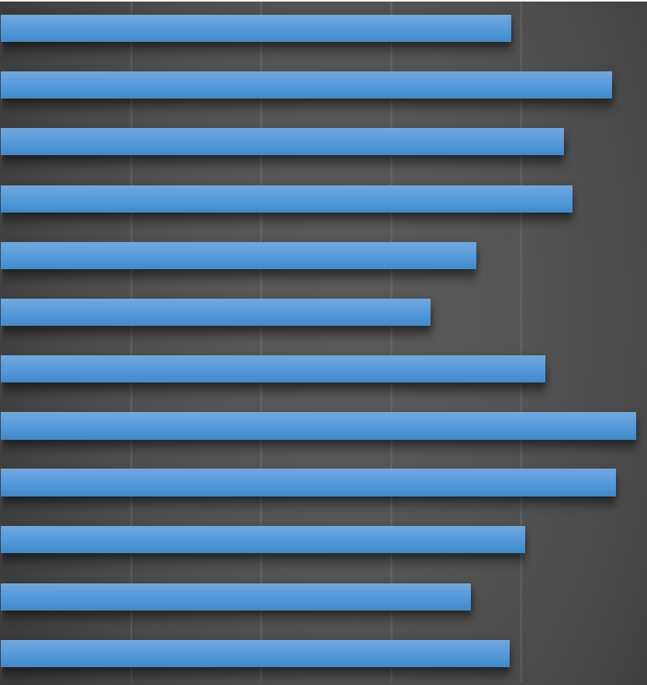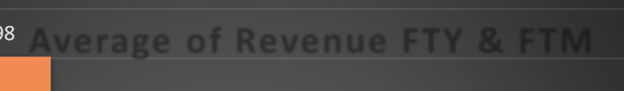

9000000

**Average Department of Salary**

8000000

803979 **Average of Revenue FTY & FTM**

Support Pune

Support Mumbai Support Bangalore

Sales Pune Sales Mumbai Sales Bangalore Operations Pune

Operations Mumbai Operations Bangalore

Accounts Pune Accounts Mumbai

Accounts Bangalore

196547

7000000

235453

217002

220006

6000000

5683561

5060797

5000000

182965

165488

4000000

209616

Total

3000000

244599

236907

2000000

201823

180992

195776

1000000

699113

440069

494223

0

0

50000 100000

150000

200000

250000

300000

Sales Bangalore

Average of Revenue (FTY)

Sales Mumbai

Sales Pune

Average of Revenue (FTM)

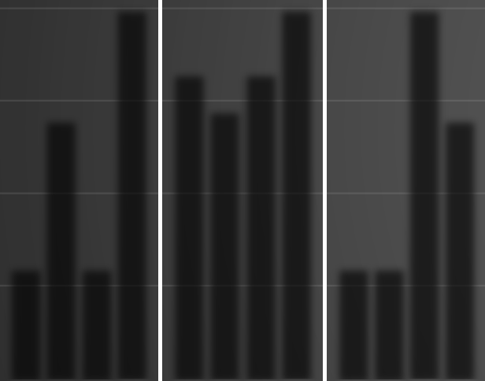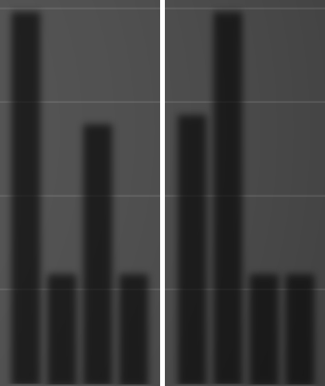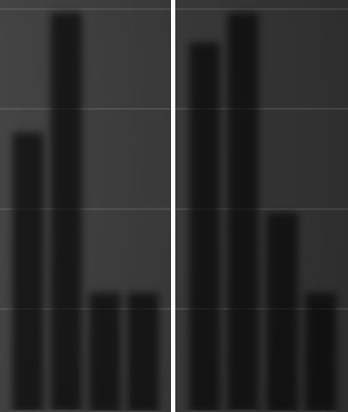

Count of Task #

60

50

40

30

Status

Closed

20

Escalated

Open Reopened

10

0

Team



**EXCEL DASHBOARD**

**Average of Salary**

**Average of Multiplier**

35400

35200

35000

34800

34600

34400

34200

34000

33800

33600

33400

33200

35167

Sales Pune

14

34500

Sales Mumbai

14

33966

Sales Bangalore

27

Bangalore Mumbai Pune 0 5 10 15 20 25 30

|  |  |  |  |  |  |  |  |
| --- | --- | --- | --- | --- | --- | --- | --- |
| Accounts | Accounts Mumbai Accounts Pune | Operations | Operations Operations Pune Sales Bangalore | Sales Mumbai | Sales Pune | Support | Support Mumbai Support Pune |
| Bangalore |  | Bangalore | Mumbai |  |  | Bangalore |  |